**1. Requirement Gathering**

Online Pharmacy

**2. Analysis & SRS**

**Step: 1 Define module/user/actor**

Guest      - Website

Customer - Website

Admin          - Admin panel

**Step: 2 Define each module Task**

**Guest:**

View category

View Product

View Doctor

View Blog

Contact us

**Customer:**

Registration

Login

View Category

View Products

View Doctor

View Blog

Special Offers

Lab Tests

Contact Us

Manage Profile

Add to Cart

Manage Cart

Place Order

Manage Order

Logout

**Admin:**

Login

Manage category

Mange Product

Manage Doctor

Manage Blog

Manage Special Offers

Manage Lab Tests

Manage Orders

View Customers

View Cart Report

View Order Report

View Lab Report

View Special Offers

**Step: 3 Define all Diagrams**

**1. Use Case Diagram:**

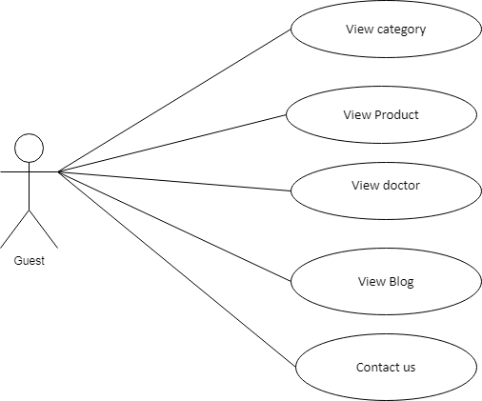

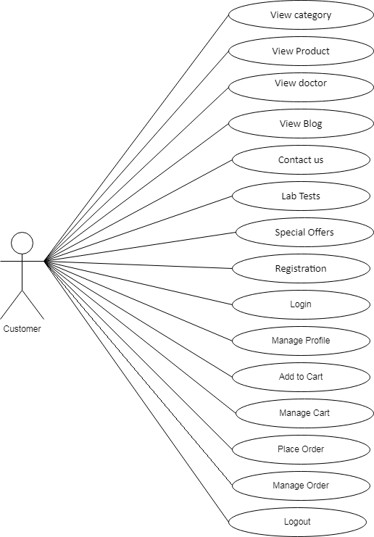

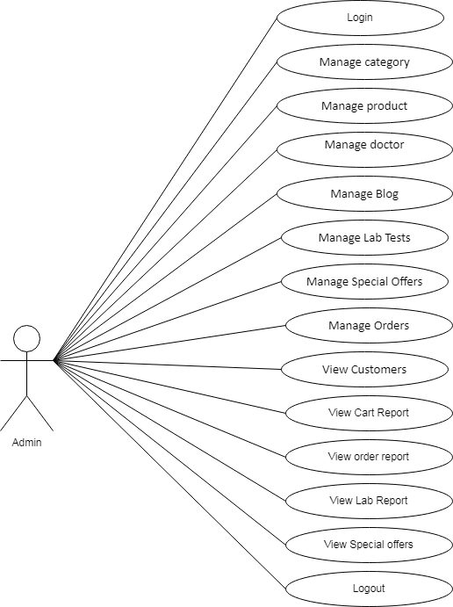

**2. DFD Data Flow Diagram**

**Level 0 / Context Level**

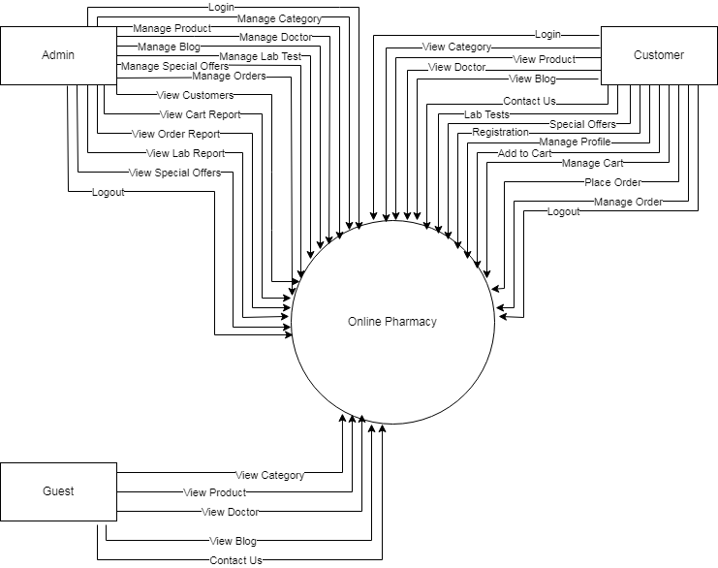

**Level 1: Admin DFD**

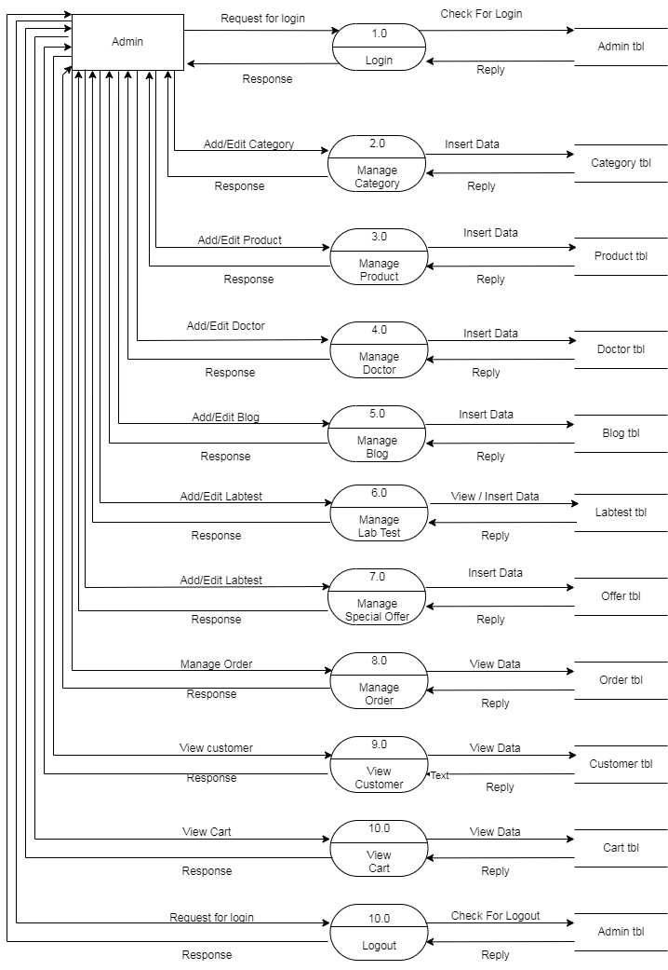

**Level 1: Customer DFD**

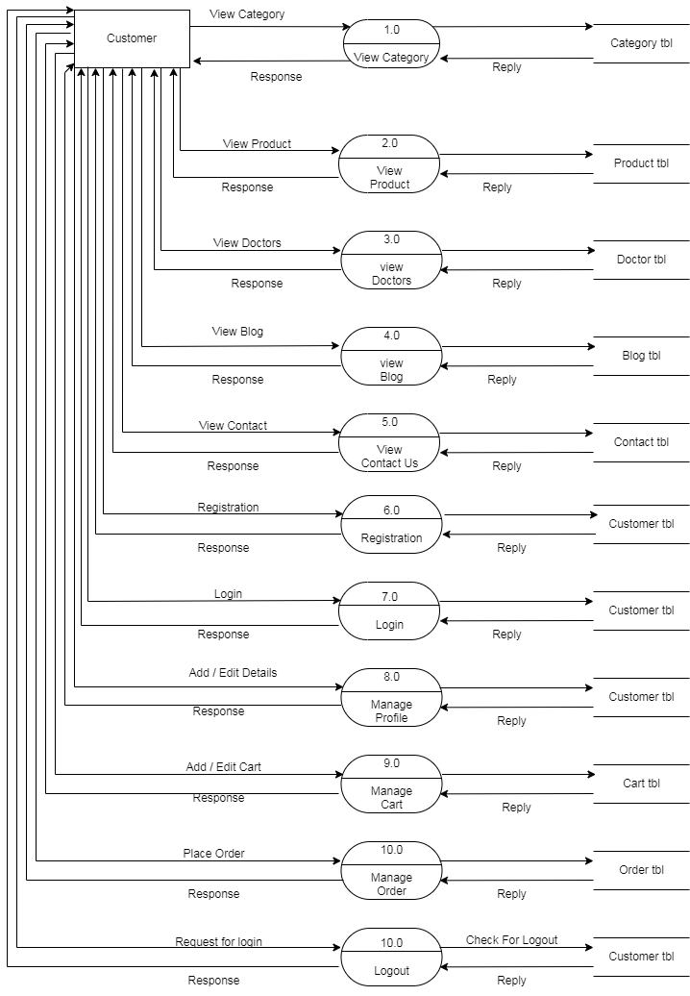

**Level 1: Guest DFD**

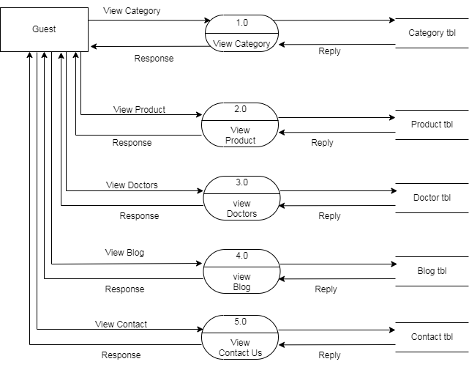

**Step: 4 Find Total Number of Table**

Category Tbl

Product Tbl

Doctor Tbl

Blog Tbl

Customer Tbl

Contact Tbl

Cart Tbl

Order Tbl

Labtest Tbl

Offer Tbl

Admin Tbl

**Step: 5 Define each Table Column**

**Category tbl:**

Category_id **PK**

Category_name

Category_img

Created _date

Updated_date

**Product tbl:**

Product_id **PK**

Category_id **FK**

Product_name

Product_mainprice

Product_img

Product_desc

Created _date

Updated_date

**Doctor tbl:**

Doctor_id **PK**

Name

Email

Mobile

Address

Created _date

Updated_date

**Contact tbl:**

Contact_id **PK**

Name

Email

Comment

Created _date

Updated_date

**Customer tbl:**

Customer_id **PK**

Name

Username

Password

E-mail

Mobile

Address

Created _date

Updated_date

**Cart tbl:**

Cart_id **PK**

Product_id **FK**

qty

Created _date

Updated_date

**Order tbl:**

Order_id **PK**

Customer_id **FK**

Cart_id **FK**

Total Amount

Created _date

Updated_date

**Labtest tbl:**

Test_id **PK**

Doctor_id **FK**

Customer_id **FK**

Test_details

Created _date

Updated_date

Offer tbl:

Offer_id **PK**

Product_id FK

Product_discprice